User audrius.sadlauskas@franmax.eu belongs to user groups :
Amigo, OrtecInfr, OrtecTest, Saperion
User config:
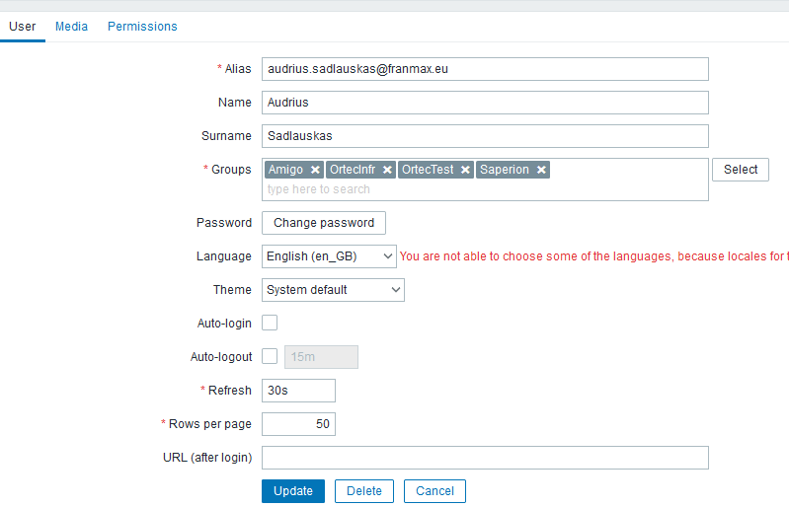
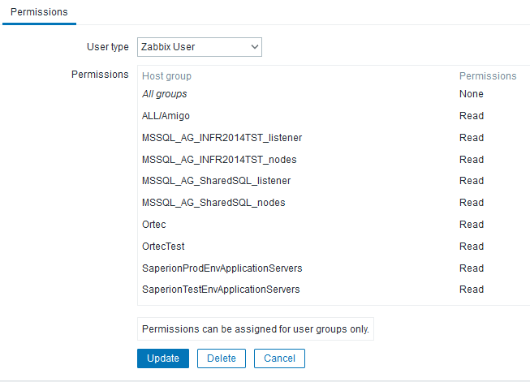

Groups config :
Group „Saperion“ :
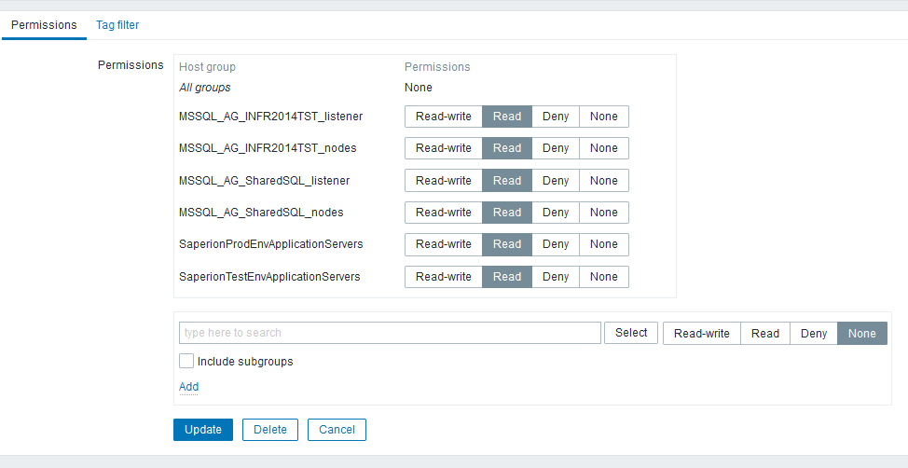

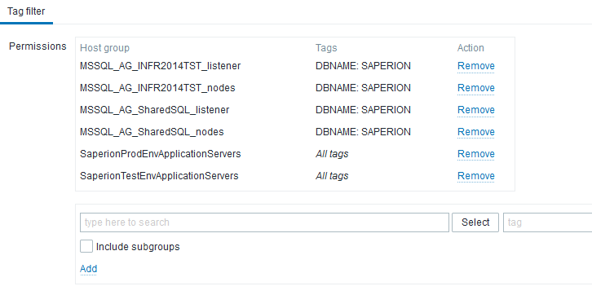
Group „OrtecTest“
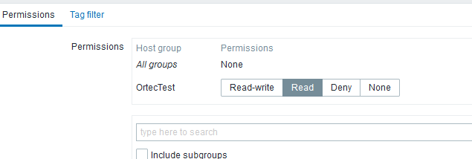

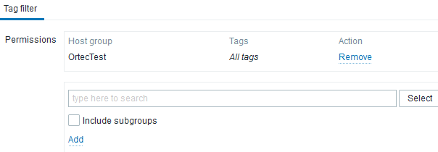

Group „OrtecInfr“
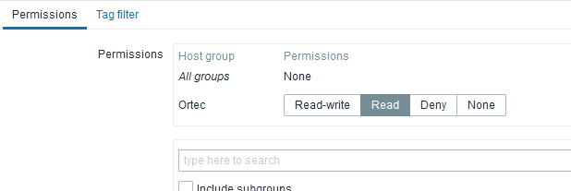
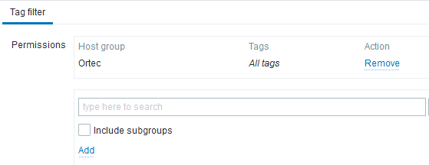
Group „Amigo“
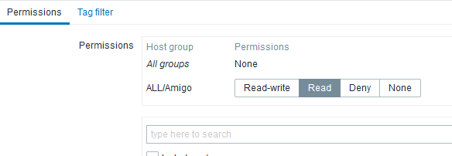
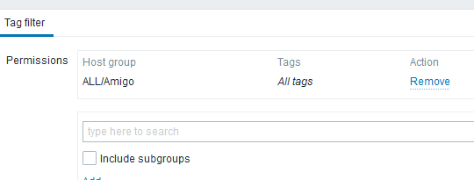

Host groups:
„Saperion“
„Ortec“
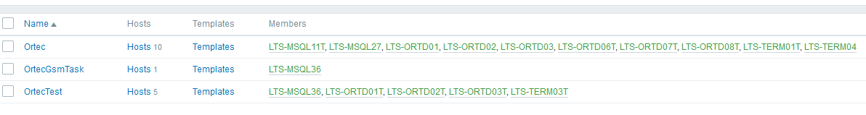
„Amigo“
User can see events from „Ortec“ host groups, but not events from Amigo, when „Saperion“ group added:
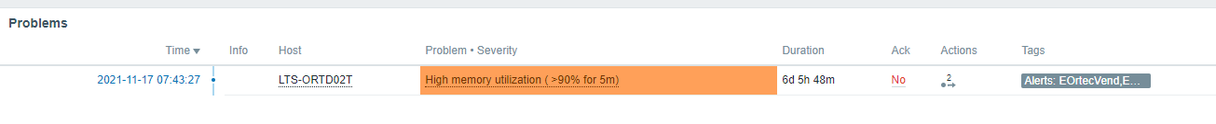
When „Saperion“ user group removed from user, „Amigo“ events can be seen:
