What happens if do alter table set compression on older versions (Postgre 9.6)? - Errors or silent failures
echo "ALTER TABLE history SET (timescaledb.compress, timescaledb.compress_segmentby = 'itemid');" | sudo -u zabbix psql zabbix
ERROR: compression is not supported with postgres version older than 10

Compression - try to add data to compressed chunk; see if it fails with error or quietly discards

CREATE TABLE test (
time BIGINT NOT NULL,
location TEXT NOT NULL,
temperature DOUBLE PRECISION NULL
);
INSERT INTO test VALUES (1577881317, 'old1', 70.0);

SELECT create_hypertable('test', 'time', chunk_time_interval => 86400, migrate_data => true);
ALTER TABLE test SET (timescaledb.compress, timescaledb.compress_segmentby = 'time');

CREATE OR REPLACE FUNCTION unix_now() returns BIGINT LANGUAGE SQL STABLE as $$ SELECT extract(epoch from now())::BIGINT $$;
SELECT set_integer_now_func('test', 'unix_now');
SELECT add_compress_chunks_policy('test', BIGINT '604800');

INSERT INTO test VALUES (1579869537, 'new1', 80.0);
SELECT * FROM timescaledb_information.compressed_chunk_stats;
"test";"_timescaledb_internal._hyper_3_2_chunk";"Compressed";"8192 bytes";"16 kB";"8192 bytes";"32 kB";"8192 bytes";"16 kB";"8192 bytes";"32 kB"
"test";"_timescaledb_internal._hyper_3_4_chunk";"Uncompressed";"";"";"";"";"";"";"";""

INSERT INTO test VALUES (1577881318, 'old2', 71.0);
ERROR: insert/update/delete not permitted on chunk "_hyper_3_2_chunk"
HINT: Make sure the chunk is not compressed.

********** Error **********

ERROR: insert/update/delete not permitted on chunk "_hyper_3_2_chunk"
SQL state: 0A000
Hint: Make sure the chunk is not compressed.

What happens when we call remove_compress_chunks_policy() when it's removed already; same with add(); measure time - we need it in HouseKeeper

SELECT add_compress_chunks_policy('history', INTEGER '604800');
ERROR: compress chunks policy already exists for hypertable "test"

********** Error **********

ERROR: compress chunks policy already exists for hypertable "test"
SQL state: 42710

SELECT remove_compress_chunks_policy('history');
ERROR: cannot remove compress chunks policy, no such policy exists

********** Error **********

ERROR: cannot remove compress chunks policy, no such policy exists
SQL state: 42704

Compression - how does it load system - to compress entire history table
Generate data (random): 1 year double precision floating point metrics:
python generate_history_rand.py
100M records
2500 item IDs
Period: 1 year (until now)
Values in range: 0.0 - 1000.0
Table size: 4977 MB

Check SELECT query performance (EXPLAIN ANALYSE <query>)

Query | Average time (milliseconds)
SELECT * FROM history WHERE clock = 1548571805; | 1879
SELECT value FROM history WHERE itemid = 20085 and clock>1548271681; | 2000
SELECT * FROM history WHERE itemid = 20000 AND clock BETWEEN 1548271681 AND 1548271681 + 86400 ORDER BY clock, itemid; | 2014

Check INSERT query performance

Query | Average time (milliseconds)
INSERT INTO history (itemid,clock,ns,value) VALUES (10001,1580109897,570943448,50.0); | 0.035

History table size before compression:
SELECT pg_size_pretty(pg_table_size('history'))
4977 MB

Enable compression:

- Convert to hypertable (locks table - select from table is waiting for this query to complete)
sudo -u postgres psql -c "\timing" -c "SELECT create_hypertable('history', 'clock', chunk_time_interval => 86400, migrate_data => true);" zabbix
Timing is on.
NOTICE: adding not-null constraint to column "clock"
DETAIL: Time dimensions cannot have NULL values
NOTICE: migrating data to chunks
DETAIL: Migration might take a while depending on the amount of data.
create_hypertable
--------------------------------------
(5,public,history_large_timescale,t)
(1 row)
Time: 232690.439 ms (0:03:52.690 – almost 4 minutes)
- Set integer now function
CREATE OR REPLACE FUNCTION unix_now() returns INTEGER LANGUAGE SQL STABLE as $$ SELECT extract(epoch from now())::INTEGER $$;
SELECT set_integer_now_func('history_large_timescale', 'unix_now');
- Set hypertable segmentation and ordering options
sudo -u postgres psql -c "\timing" -c "ALTER TABLE history_large_timescale SET (timescaledb.compress, timescaledb.compress_segmentby = 'itemid', timescaledb.compress_orderby = 'clock, ns');" zabbix
Timing is on.
NOTICE: adding index _compressed_hypertable_6_itemid__ts_meta_sequence_num_idx ON _timescaledb_internal._compressed_hypertable_6 USING BTREE(itemid, _ts_meta_sequence_num)
ALTER TABLE
Time: 43.201 ms (0:00:00.043 – 43 milliseconds)
- Enable automatic chunk compression policy
sudo -u postgres psql -c "\timing" -c "SELECT add_compress_chunks_policy('history_large_timescale', INTEGER '604800');" zabbix
Timing is on.
add_compress_chunks_policy
----------------------------
1004
(1 row)

Time: 11.650 ms (0:00:00.011 – 11 milliseconds)
- All further compression was performed by background job between 13:55:30 and 14:02:54 (duration: 0:07:24)

System load during compression (13:55:30 - 14:02:54):

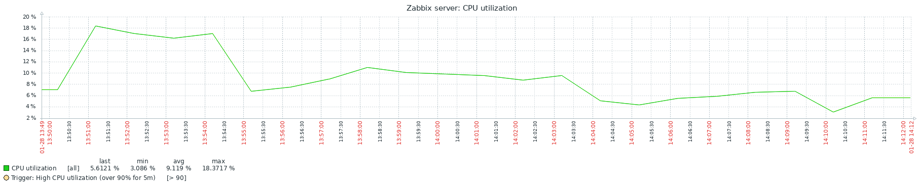
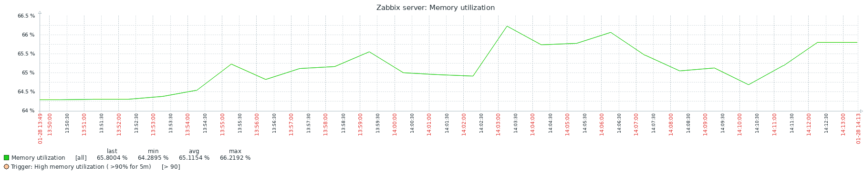

On my local PostgreSQL installation no any significant system loads were noticed during history table compression.

History table size after compression:

SELECT * FROM timescaledb_information.compressed_hypertable_stats;

total_chunks | 366
number_compressed_chunks | 358
uncompressed_heap_bytes | 4886 MB
uncompressed_index_bytes | 0 bytes
uncompressed_toast_bytes | 0 bytes
uncompressed_total_bytes | 4886 MB
compressed_heap_bytes | 1408 MB
compressed_index_bytes | 34 MB
compressed_toast_bytes | 2864 KB
compressed_total_bytes | 1445 MB

Compression ratio: 1445 MB / 4886 MB = 0.295742939

Check SELECT query performance (EXPLAIN ANALYSE <query>)

Query | Average time (milliseconds) | Ratio
SELECT * FROM history WHERE clock = 1548667614; | 1.5 | 0.0008
SELECT value FROM history WHERE itemid = 20085 and clock>1548271681; | 160.0 | 0.008
SELECT * FROM history WHERE itemid = 20000 AND clock BETWEEN 1548271681 AND 1548271681 + 86400 ORDER BY clock, itemid; | 0.170 | 0.000084

Check INSERT query performance

Query | Average time (milliseconds) | Ratio
INSERT INTO history (itemid,clock,ns,value) VALUES (10001,1580109897,570943448,50.0); | 0.035 | 1.0

Same as before switching to compressed hypertable

Insert into compressed chunk:
INSERT INTO history (itemid,clock,ns,value) VALUES (10001,1549065601,570943648,55.0);
ERROR: insert/update/delete not permitted on chunk "_hyper_1_7_chunk"
HINT: Make sure the chunk is not compressed.

********** Error **********

ERROR: insert/update/delete not permitted on chunk "_hyper_1_7_chunk"
SQL state: 0A000
Hint: Make sure the chunk is not compressed.
SELECT * FROM chunk_relation_size('history');

